Minister Schulz,
Thank you for your engagement and the responses provided by your staff. We appreciate your time in meeting with us and look forward to a chance for more in-depth discussion on these issues. The number one ask from our community is for the government to move to phase out all freshwater use for hydraulic fracturing. This is a long term goal. In the interim there are other small steps that may be taken, to move towards that goal, which will not require such high-level change and will build public confidence that the government is moving in the right direction. Please see below for details.
As residents of the Red Deer River watershed, we fall under the South Saskatchewan Water Management Plan (SSWMP), which is meant to guide water management in our basin. We believe it is important to refer this plan and use it as a touchstone to guide future action. In 2018, a 10-year review of the plan was completed for Alberta Environment and the following three opportunities were highlighted:
Opportunity 1: Continue to involve collaborative groups in watershed management
Opportunity 2: Provide clarity, transparency and information on the decision-making processes implemented through the Plan
Opportunity 3: Implement programs and actions beyond the Plan that will not only prevent further degradation, but improve the long-term health of the aquatic environment
We strongly support all three of these opportunities, which mirror the current issues in our area. Since it has been seven years since this review was completed, it is useful to look at past goals to recognize successes, as well as shortcomings, and there are some of each to highlight with respect to our ongoing discussions. Let’s start with the third and move backwards.
Opportunity 3 relates to our concerns about the need to better protect our surface waters. Alberta’s rivers and lakes are a large part of what give Albertans our amazing quality of life and make this province such a beautiful place to live. Our communities are concerned that current protections are insufficient, and this mirrors the recommendations in the review.
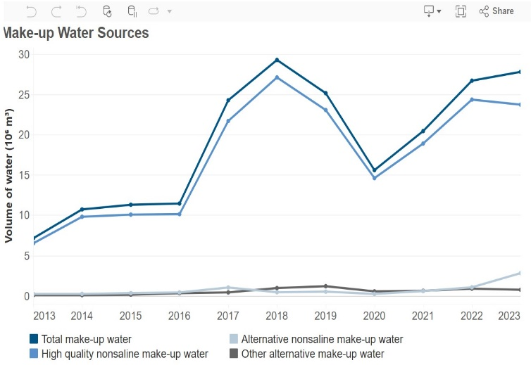
Water use demands in our area are increasing significantly while the mean annual discharge of our rivers is declining. When the reality on the ground changes, as it has, it is the job of government to undertake policy review. The need for stakeholder engagement should not be used as a reason to avoid this. The 2018 SSWMP review highlighted the need to review Water Conservation Objectives (WCOs) to ensure they were meeting their stated purpose and look at improvements or possible alternatives. We feel our request is an example of this and should be initiated.
The suggestion of using Surface Water Allocation Directive (SWAD) at higher flows, and Instream Objectives (IOs) at lower flows, would be a positive interim step, if applied to Term and Temporary licences on both rivers. Better protections for both the Medicine and Blindman rivers should be studied, particularly with the long-term downward trends in both annual precipitation and annual discharge in our local rivers, after which public consultation could occur. The Battle River WCO could be a starting point, as the Battle River has many similarities, hydrologically, with our watersheds.
Opportunity 2 also has some successes and failures. The recent transition to the map-based Environmental Records Viewer platform for searching and viewing water licences and applications is a great improvement over the previous search-based platform. Moving licences into DRAS to allow for online reporting makes it much easier for licence holders and will help streamline monitoring and compliance as well. Both changes are very significant and are commended.
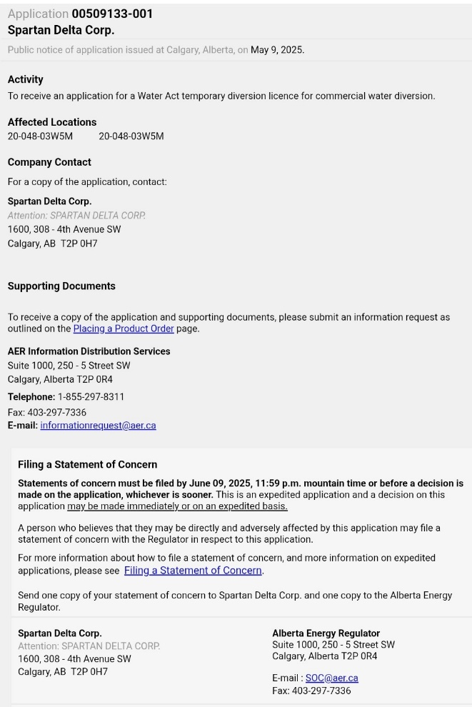
A failure that needs to be addressed is the AER’s application process and approval of TDLs. Many of these TDLs are hundreds of thousands of cubic metres, which in a single year uses a larger volume than the total 25-year allocation of many local agricultural term licences -which do require advertised public notice. In the most recent correspondence with our group, Ministry staff noted that the AER has public notice for TDLs — this is not exactly true. The requirement is for the TDL application notice to be posted on the AER PNOA website for 30 days (but not advertised), and the application details are not posted. If someone wants to know the source of water, or the volume of water being applied for, they must contact the applicant to request a copy. Any Statement of Concern must then be submitted to the AER and the company, all within 30 days. Many companies have only a mailing address as contact information (see sample TDL application notice). This should not be allowed. The AER needs to post the volume and source on the PNOA site, along with an email and/or phone number for the applicant. Large volume TDL applications should also be advertised.
While many AER licencing decisions are not transparent and there is little clarity to the public, the above recommendation would be an easy solution to one specific problem.
Additionally, the 2018 review of the SSWMP stated, “there is concern that Temporary Diversion Licences may increase in the future and that the impacts of this increase - on both surface and groundwater - are uncertain.” This has proven to be a valid concern, and we worry that industry is using the less regulated TDL system to avoid looking at alternatives. TDLs need to fall under the AER’s Manual 25.
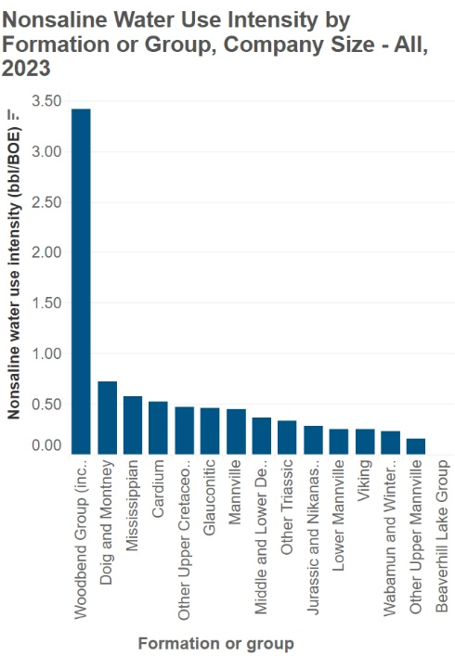
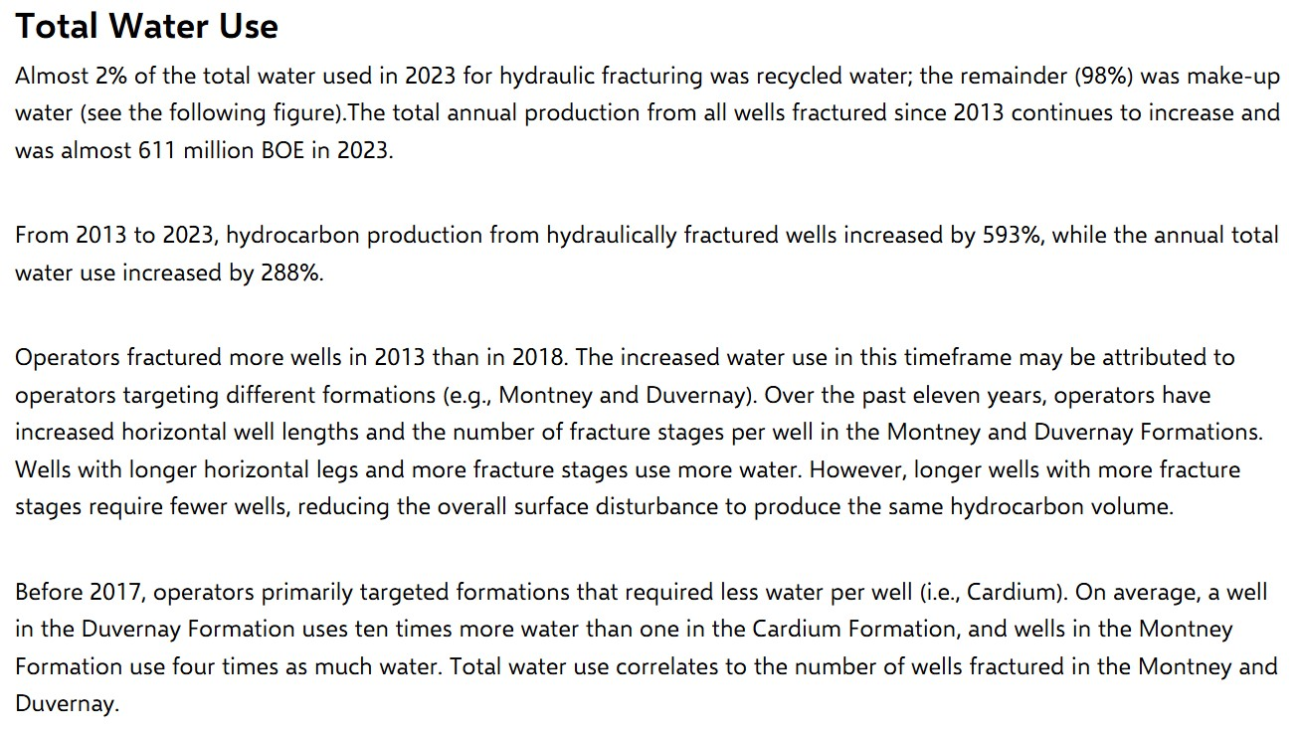
Another shortfall is that the directives and regulations have not kept up with changes in industry practice. We believe the current regulations, were never designed to manage such large-scale use of freshwater for hydraulic fracturing. The exploration in our watershed is occurring in the Duvernay (part of the Woodbend Group) and is particularly water intensive, requiring 8-10 times more water than other formations in the province (see AER water-use graph). The AER recognizes that since 2017, water use for hydraulic fracturing fundamentally changed due to new exploration techniques and the development of the Duvernay formation (see AER Total Water Use cutoff below).

At the core of this issue is that hydraulic fracturing is fundamentally a different use of water than other uses, as it is a complete disposal and is not available to be used again by others. There are also alternatives to using freshwater for hydraulic fracturing, which are not available to other users.
Another immediate improvement in encouraging alternative water use and improved efficiency, could be achieved by making a minor adjustment to AER’s Manual 25 risk assessment tiers by having any large-scale projects in Potentially Water Short Areas fall under Tier 4 instead of Tier 3.
While the above suggestions could be implemented, among many other possible tweaks to the current regulations and directives, most of the concerns our community has around freshwater licencing, monitoring and compliance would be made redundant if freshwater allocations for hydraulic fracturing were to be phased out.
No freshwater for fracking should be the stated long-term goal by Alberta Environment.
This should happen over several years, beginning in Water Short Areas, then Potentially Short Areas and eventually the rest of the province. This would give industry direction and time for innovation and planning.
Finally, with respect to Opportunity 1, we appreciate your attention to our concerns around freshwater management, as well as your commitment to continued communication with watershed groups such as ours. We believe continued involvement of watershed groups, in policy development and communicating with communities, will become ever more important.
Thank you again for your attention to this matter. We understand water management is complex, involves many competing interests and solutions require thoughtful conversations. We look forward to further discussions in the future.

Sincerely,

Dana Kreil
President, Medicine River Watershed Society

Assar Grinde
President, Friends of the Blindman

